FAST EXPONENTIAION

(ITERATIVE)
(BINARY EXPONENTIATION)

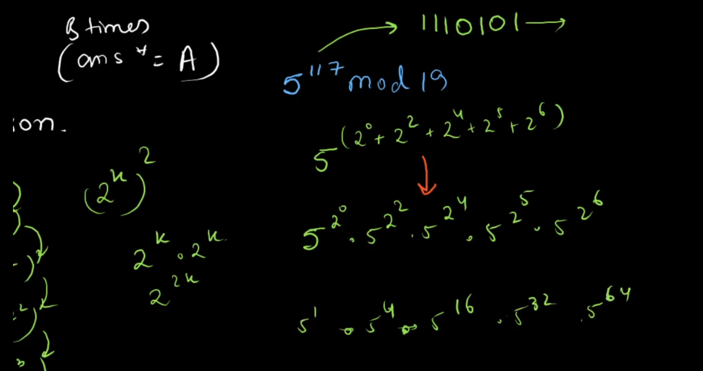
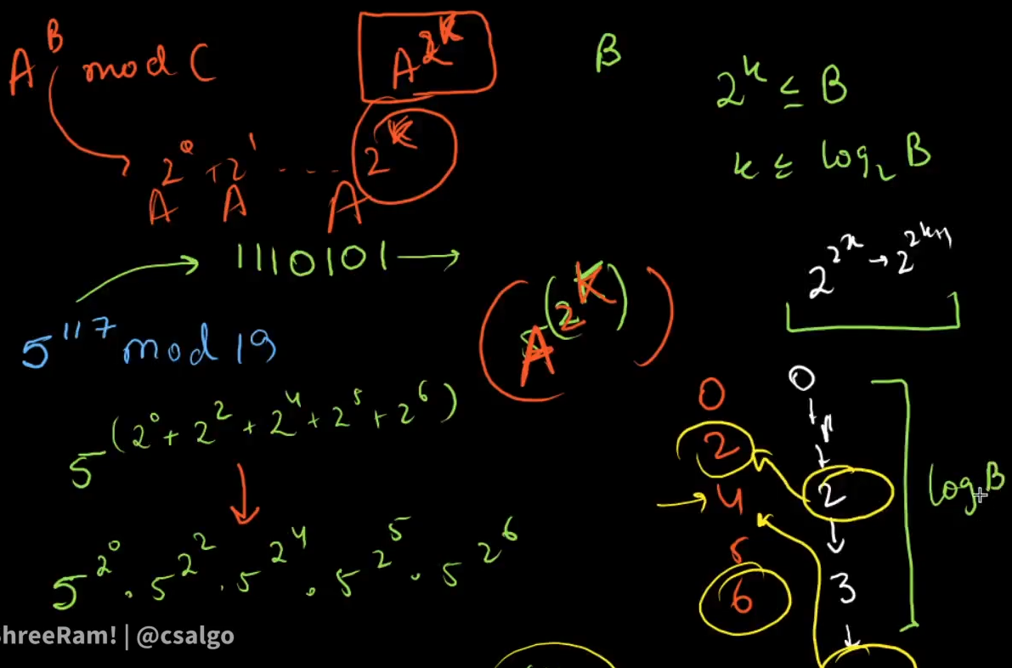
#include <iostream>
using namespace std;
int fastexpo(int a, int b, int mod)
{
int ans = 1;
while (b)
{
if (b % 2 == 1) // 1011 this is binary form eg then this is used to check weather the last bit is zero or 1 if 1 it means to multiply the ans with a
{
ans = (1LL * ans * a % mod);
}
a = 1LL * a * a % mod; //eg 1001 means 2^0*2^3 only
b = b / 2; //divide each time to go to next bit it can be done using bit manipulation
}
return ans;
}
int main()
{
int a, b;
cin >> a >> b;
cout << fastexpo(a, b, 1e9 + 7) << "\n";
//calculating mod inverse
cout << fastexpo(a, 1e9 + 7 - 2, 1e9 + 7); //a^(p-2) by little theorem
}

